**1. Introduction:**

Welcome to the **Art Dealer Game**, an interactive and fun card pattern matching game designed for students in grades 3-5. In this game, you will act as an art gallery owner trying to figure out which pattern of paintings (cards) the art dealer is looking to buy. This game will help you develop computational thinking skills and improve your ability to recognize number patterns.

**2. Game Setup:**

* Ensure that you have Python installed on your computer.
* Install the necessary libraries:
  + tkinter for the game interface.
  + pygame for game sound effects.

To install these, you can use the following commands in your terminal:

* pip install pygame
* pip install tkinter

Make sure the sound file (gameplay_sound.mp3) is in the same directory as the game file.

**3. How to Play:**

* When the game starts, a deck of cards will be shuffled, and a hand of cards will be dealt to you.
* Your goal is to identify the pattern that these cards form. The possible patterns are listed below:
  1. **All Even Numbers** – All cards in your hand are even numbers.
  2. **All Odd Numbers** – All cards in your hand are odd numbers.
  3. **Sum of Values Greater than 20** – The total value of your hand is greater than 20 (face cards count as 10).
  4. **Two Red and Two Black Cards** – You have two red-suited cards and two black-suited cards.
  5. **All Cards of Different Suits** – Each card is from a different suit.
  6. **Two Picture Cards** – Your hand contains two face cards (Jack, Queen, King).
  7. **Prime Numbers and a Face Card** – You have prime-numbered cards and one face card.
  8. **Two Cards Add Up to 10** – Two cards in your hand add up to 10.
  9. **All Cards Greater than 5** – All the cards in your hand are greater than 5.
* Based on the cards you receive, make your selection of the correct pattern.
* If you select correctly, you win the round. If not, you can try again with a new set of cards.

**4. Controls:**

* **Start Game**: Begins a new round by shuffling the deck and dealing a new hand of cards.
* **Select Pattern**: Choose the pattern that matches your current hand.
* **Reset Game**: Shuffle the deck and start again if you wish to try a new hand.
* **Exit**: Close the game window and exit.

**5. Game Sound Effects:**

* The game includes sound effects to enhance the gameplay experience. Make sure your sound is enabled, and enjoy the auditory feedback as you play.

**6. Game Rules and Tips:**

* Pay attention to the patterns that have been previously selected.
* Each round is independent, meaning the patterns can repeat, but the cards are shuffled randomly.
* If you're stuck, take a closer look at the suits, numbers, and overall values of the cards.

**7. Troubleshooting:**

* If the game doesn’t start, check that all the necessary libraries are installed and that the sound file is in the correct directory.
* If the game crashes or a window doesn’t open, ensure that you’re running the game in a Python environment that supports Tkinter and Pygame.

**8. Conclusion:**

The **Art Dealer Game** is a fun and educational tool to help develop pattern recognition and computational thinking skills. Designed for students in grades 3-5, it provides a challenging yet enjoyable experience that reinforces math concepts in an interactive way.

**Projects Screenshot:**

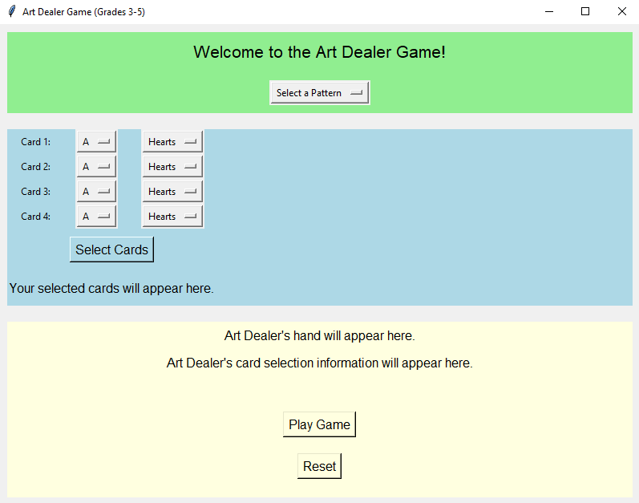

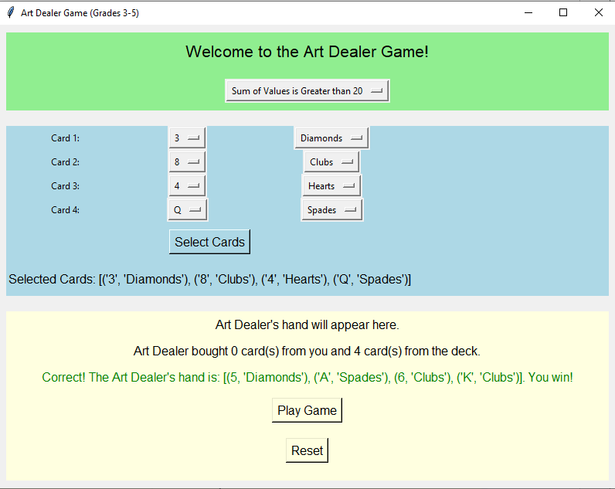

We selected the cards from drop down menus, and then select the pattern.  
At least one of the selected patterns must be true.